Market Research Report: Anonymous Real-time Classroom Q&A Platform

User Group Profile

The primary users of this platform are high school students (ages 14 to 18) and college students (ages 18 to 24), especially those who are reluctant to ask questions in class due to anxiety, fear of embarrassment, or peer judgement. These students often feel the pace of lectures is too fast to pause for every question. Secondary users are instructors and professors who want systematic ways to capture questions, prioritize them (especially commonly asked or confusing questions), manage class time efficiently, and decide which questions to handle live versus after class.

Survey research supports these insights. For instance, a 2021 study by Nadile et al. found that many undergraduates in large-enrollment science courses report feeling uncomfortable voluntarily asking or answering questions in front of the class. [PMC](https://pmc.ncbi.nlm.nih.gov/articles/PMC7802933/?utm_source=chatgpt.com) A related study, *Gender Differences in Student Comfort Voluntarily Asking…* found that over half of surveyed students never ask questions in such settings, often due to fear of negative evaluation or judgement. [PMC](https://pmc.ncbi.nlm.nih.gov/articles/PMC8439613/?utm_source=chatgpt.com)

Additional data show students are more likely to “lurk” rather than actively participate in class discussion when visibility is required. Research in science education reveals that large classes exacerbate this problem, particularly among students from underrepresented or first-generation backgrounds. [arXiv+1](https://arxiv.org/abs/1901.01061?utm_source=chatgpt.com)

Market Size & Opportunity

There is strong demand for classroom tools that support student engagement, participation, and question management. According to Grand View Research, the global education technology (EdTech) market was valued at approximately USD 163.49 billion in 2024 and is expected to grow at a compound annual growth rate of about 13.3% to reach around USD 348.41 billion by 2030 (Grand View Research, 2024).

In the United States, Ken Research reports that the EdTech market was approximately USD 42 billion in 2023, with continued growth projected through 2030 (Ken Research, 2023). A substantial portion of this market is focused on software tools, platforms, and engagement technologies in K-12 and higher education, indicating opportunity for solutions addressing student participation anxiety and question management. HolonIQ reports that education is one of the world’s largest industries and remains heavily under-digitized, further highlighting the potential for growth (HolonIQ, 2024).

To estimate scale, there are about 5,916 U.S. post-secondary institutions, including colleges and universities (NCES, 2022). Additionally, there are approximately 26,727 public and private high schools in the country (Mission Graduate, 2022). Assuming a conservative adoption rate of 5–10% of these institutions, and considering that each adopting institution might use the platform in 10–20 classes per term with average class sizes of 50 or more students, the potential user base could reach hundreds of thousands to millions of students over multiple semesters.

Citations:

Grand View Research. (2024). Education Technology Market Size, Share & Trends Analysis Report By Technology, By End Use, By Region, And Segment Forecasts, 2024–2030. Retrieved from <https://www.grandviewresearch.com/industry-analysis/education-technology-market>

Ken Research. (2023). U.S. Education Technology Market Report 2023. Retrieved from https://www.kenresearch.com/industry-reports/us-education-technology-market

HolonIQ. (2024). EdTech in 10 Charts. Retrieved from https://www.holoniq.com/edtech-in-10-charts

National Center for Education Statistics (NCES). (2022). Fast Facts: Number of Postsecondary Institutions. Retrieved from https://nces.ed.gov/fastfacts/display.asp?id=1122

Mission Graduate. (2022). Number of Schools in the U.S. Retrieved from https://missiongraduatenm.org/number-of-schools-in-the-us/

Competitor Analysis

Here are two to three existing apps or systems, their real-world features, and where gaps remain (supported by sources):

* **Slido** — Offers anonymous Q&A, upvoting/prioritization, works in live sessions and in advance, integrates with slide tools and video conferencing platforms. Weaknesses: follow-up structure after class is minimal; overwhelmed by many questions without grouping or deduplication; cost/licensing can be a barrier for institutions with limited budgets.
* **Vevox** — Has live anonymous Q&A, polls/surveys, good lecture tool integration. Weaknesses: does not always provide strong mechanisms for deferred responses after class; question similarity clustering is weak; setup/training overhead can be nontrivial.
* **Mentimeter / Wooclap** — Strengths include engaging visuals, multiple question types, easy entry for students via QR codes, anonymity options. Weaknesses: more oriented toward polls/interactive activities rather than sustained question threads; prioritization/upvoting features may be less robust; follow-up or deeper content delivery after class is less emphasized.

One academic work of note is *“Towards a Live Anonymous Question Queue To Address Student Apprehension”* (Montgomery et al., 2019, arXiv) which studies a similar concept (LAQQ) and identifies what features are most needed (notification of submissions, question context, ease of access, institutional adoption) along with usability across platforms. [arXiv](https://arxiv.org/abs/1901.01061?utm_source=chatgpt.com)

Unique Value Proposition

This platform would be differentiated in the following ways:

* Automatically anonymous for student submissions, with optional identity disclosure only visible to instructors.
* Real-time question submission along with upvoting/prioritization so instructors can identify which questions affect many students.
* Flexible response modes: live answers during class plus persistent after-class responses (written or video) that students can access later.
* Clustering or deduplication of similar questions to reduce redundancy and overload.
* Low friction setup (e.g., joinable via link or QR code, works with existing slide tools), plus moderation tools for instructors.

These features matter because, as research shows, many students are held back by fear of judgement, especially in large classes; they want participation tools that protect dignity and allow voice without exposure. The ability for instructors to triage and manage questions helps preserve lecture flow without neglecting student comprehension.

Visualization

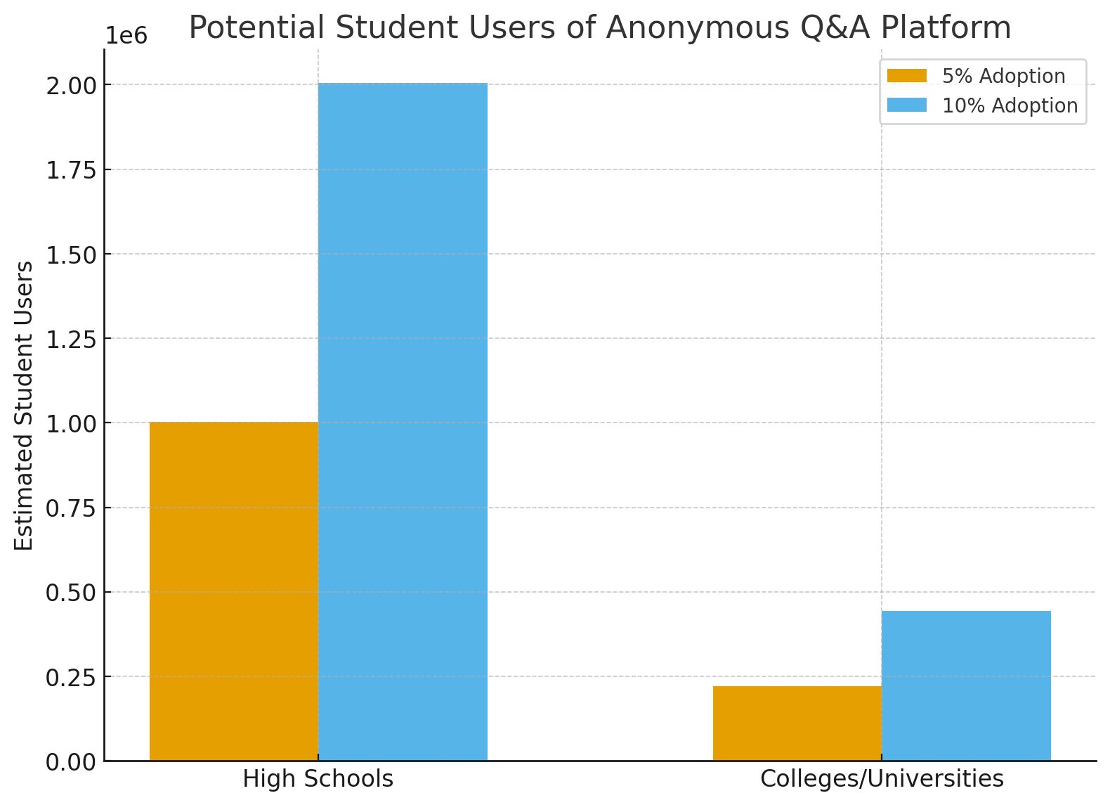

Conclusion

There is clear demand for anonymous real-time Q&A platforms to help students who are uncomfortable asking questions in class. Current tools offer many useful engagement features but leave important gaps: post-class follow-up, clustering, strong anonymity, and easy prioritization. A well-designed platform that fills those gaps could significantly improve classroom discussion, comprehension, and equity, particularly in large or fast-paced lecture settings.

Generative AI Transparency Statement

I used a generative AI (ChatGPT) to help structure, draft, and refine parts of this report. Specifically:

* Prompt: I asked for a market research report about an anonymous real-time classroom Q&A platform, with sections including user group profile, market size/opportunity, competitor analysis, unique value proposition, etc.
* Verification: I then cross-checked AI outputs against peer-reviewed academic studies and reputable industry reports (e.g. Nadile et al., Grand View Research, Ken Research) to ensure the data are accurate and sources credible.